

Information System and Design – Assigment 4

[Document subtitle]



March 19, 2020

Contents

Introduction 2

Queries - Creating Tables 3

Administration 3

Assignment 4

Class 5

Course 6

Department 7

Module 8

Staff 9

Student 10

Relationships 11

Tables: Datasheet View 12

Administration 12

Assignment 13

Class 14

Student 15

Student 16

Module 17

Department 18

Course 19

Tables - Design View 20

Administration 20

Assignment 21

Student 22

Class 23

Course 24

Department 25

Module 26

Staff 27

Forms 28

Design Form 28

Splash Screen 28

Login Screen 29

Main Menu 30

Form Page 31

Administration Form 32

Assignment Form 33

Class Form 34

Course Form 35

Department Form 36

Module Form 37

Staff Form 38

Student Form 39

Queries and Report 40

Form View 41

Splash Screen 41

Login Screen 42

Main Menu 43

Forms 44

Administration 45

Assignment 46

Class 47

Course 48

Department 49

Staff 50

Student 51

Queries and Reports 52

Quires and Reports 53

All grades 53

All Staff and Modules 54

Marks Search by Module Name 55

Extra Modules 56

Reports 57

All staff and Modules 57

Student Grades 60

Conclusion 0

# Introduction

For this assignment, I am finalising my databases from the ABC case study. I am aiming to implement my designs with the relationship entity life and implementing it within Microsoft access. Within access I will be creating and forming tables via SQL to make precise tables and validations without the use of assistance from the excess tools that that application provides. Using SQL, I can be precise how each table are formed and implement validation for each attribute. Once the tables are created and filled with data, I will be creating forms from the database to provide a more graphical display of the user interface allowing users to be able to access and navigate through each forms and data and edit/add/delete to their pleasure. This GUI (graphical user interface) will follow a simplistic interface which will be aesthetically pleasing to look at and will be designed in a professional manner to keep the spectrum of the database to match the ethos of the college. Within these forms the user’s will have access to extra queries functions to provide more accessibility to their database to look for specific researches or entities with certain relationships. Other forms on the GUI will be reports which will report mass amount of data within a more compact clean look. This will usually be the big aspect of the database for users to look at and analyse the data within to report.

This will be the final documentation of ABC College but the documentation is key to show how each entities and attributes work with each other within the database, this documentation will show all the development being implemented into one big user database which the ABC college can use and implement within their own program. This documentation will show each queries and functions and relationships and how each element can be used to create an efficient database.

# Queries - Creating Tables

To create tables I used SQL to form my tables whilst assigning attributes to the entities, I also used the queries to connect the relationships with primary keys and foreign keys to each table.

## Administration

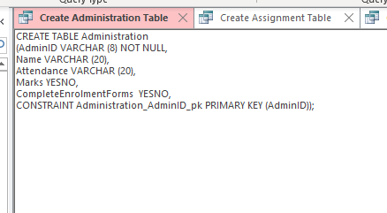

The CREATE TABLE function creates the table that the user wants, the next couple of lines will contain the lines of code and validations next to each attributes, as an example Marks YASNO makes it so that this Marks are only a check list where Attendance has the character limit of 20. With “CONSTRAINT” this forces AdminID to become a primary key.

## Assignment

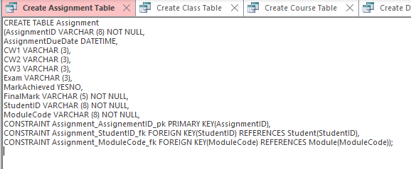

Within this screenshot, we can see there’s a second “CONRSTRAINT” which implements a forging key that that table can use

## Class

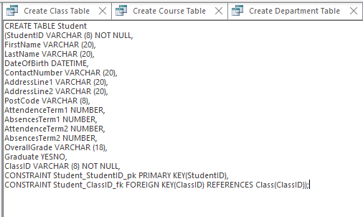

## Course

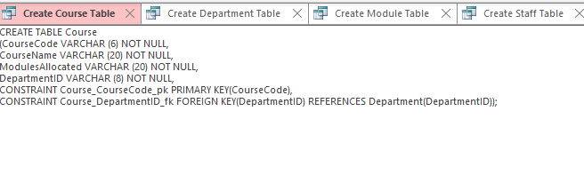

## Department

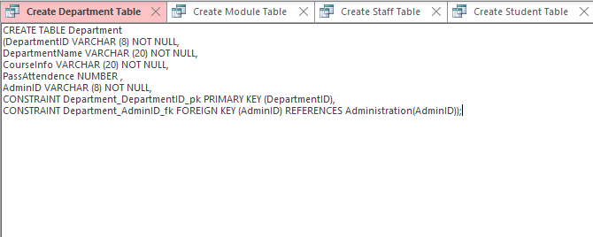

## Module

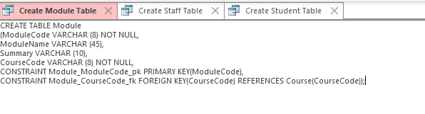

## Staff

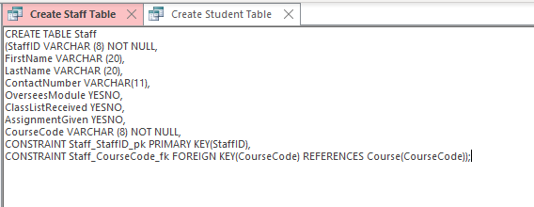

## Student

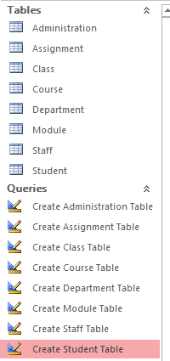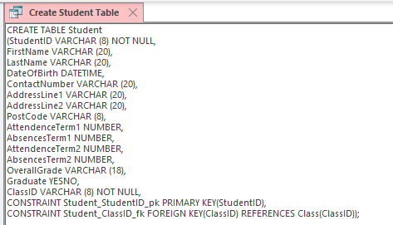

Once all the queries have run, they will produce the tables with all the code within SQL should result in the database looking like this. The users can now look at the tables and see all the attributes within the entities.

## Relationships

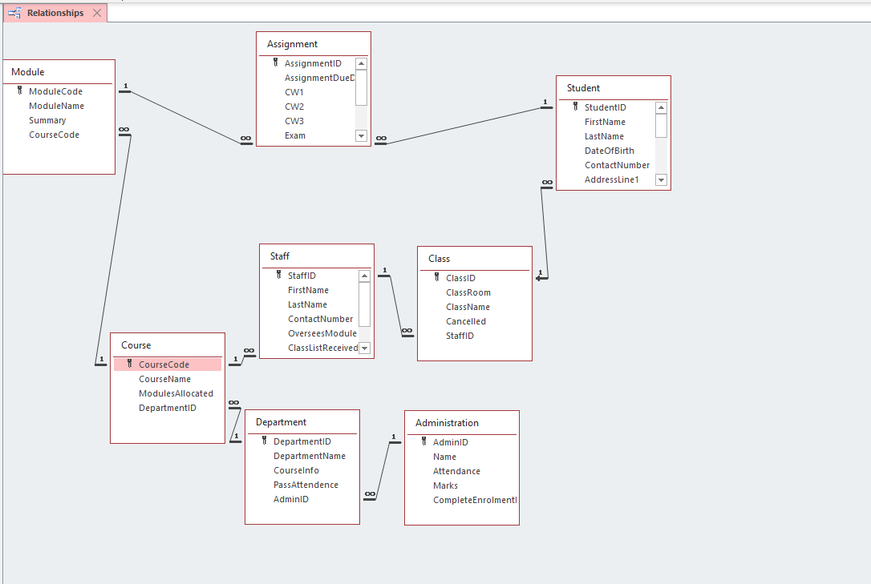

Whist all the tables have been created; you can now also see all the relationships with each entity and users are able to see the primary and foreign keys for each relationship.

# Tables: Datasheet View

## Administration

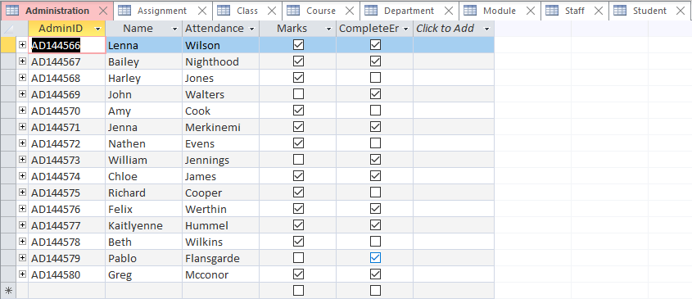In the datasheet view, you can see all the attributes and entities filled with data, you also get to see the different aspects with the different validations of YESNO with the check boxes and the automated ID’s on the admin ID’s.

## Assignment

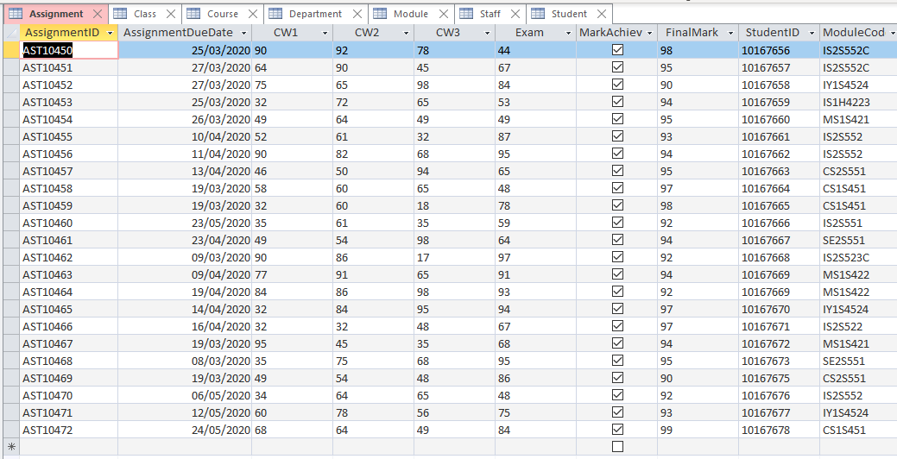

## Class

## Student

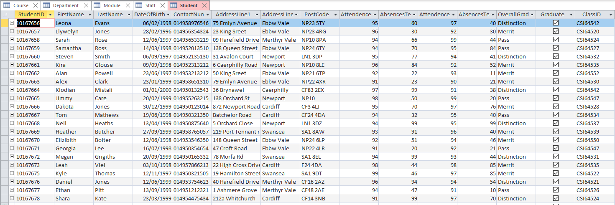

## Student

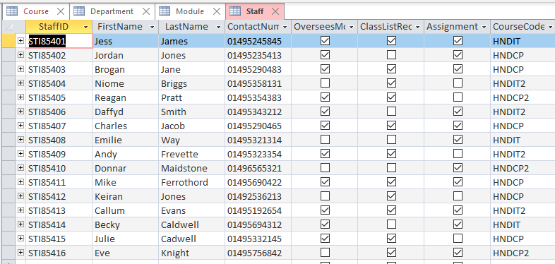

## Module

## Department

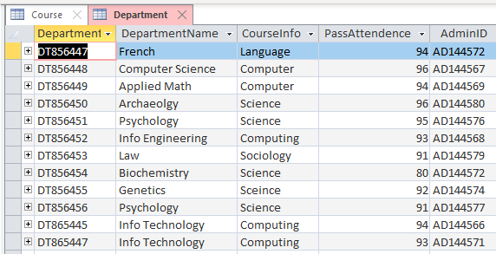

## Course

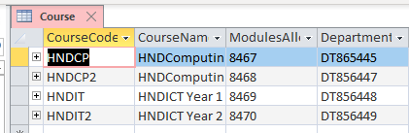

# Tables - Design View

## Administration

In the design view, you can see the field names and data types associated to each table. When it comes to this view, it should follow the validation that was encoded within SQL which it has within this screenshot as marks and completed forms when making the table where the “YESNO” Datatype which can be seen in this screenshot that it has been executed like this.

## Assignment

In this screenshot I implemented date/time which allows users to pick dates for their field.

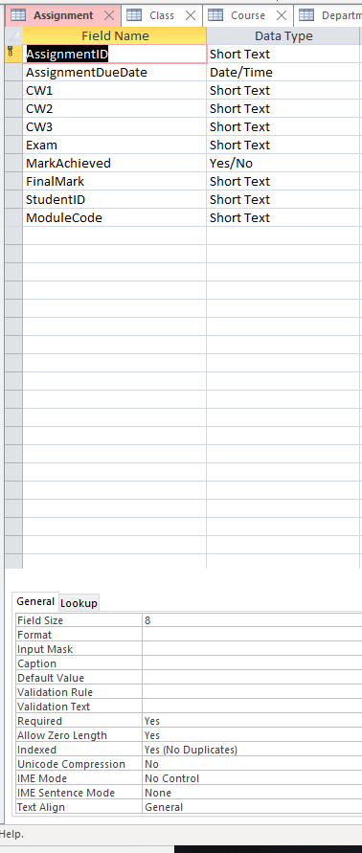

## Student

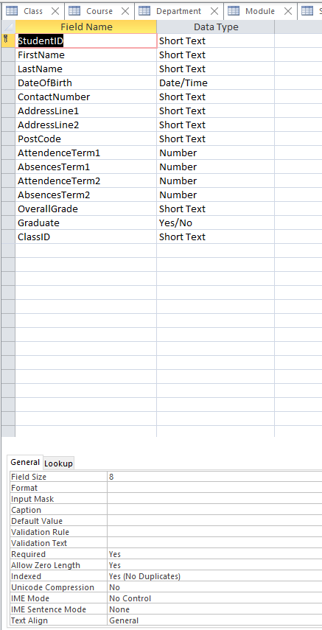in this screenshot another validation used is Number which makes it so only numbers can be entered within the field

## Class

## Course

## Department

## Module

## Staff

# Forms

This is the graphical user interface which is where users can navigate use the database in a cleaner format

## Design Form

### Splash Screen

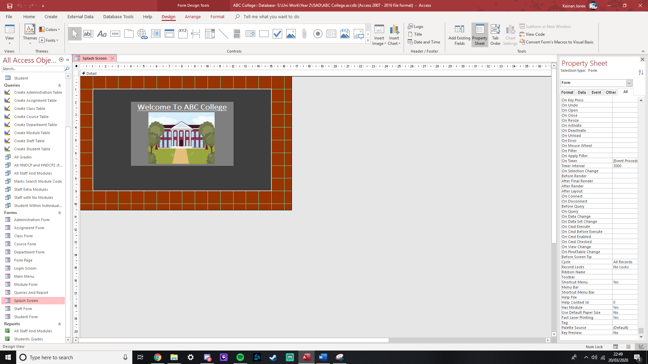

This is the splash screen that I created for when the user launches the GUI, this splash screen helps load up the database in the background by displaying a soft image welcoming the user

### Login Screen

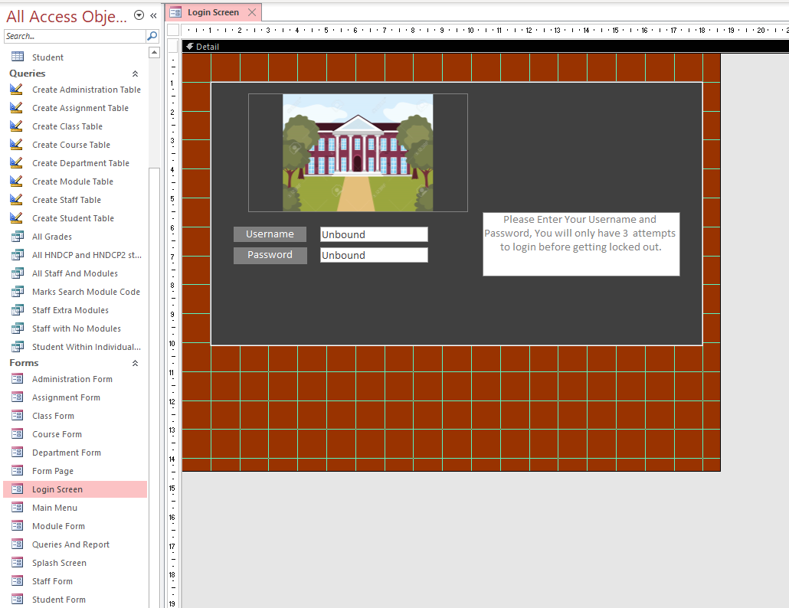

This is the login screen that staff/admins will be greeted with. The login has a message telling users to enter their username and password. They also have only 3 chances to sign in otherwise the database will close. Once logged in, the database will load the menu page

### Main Menu

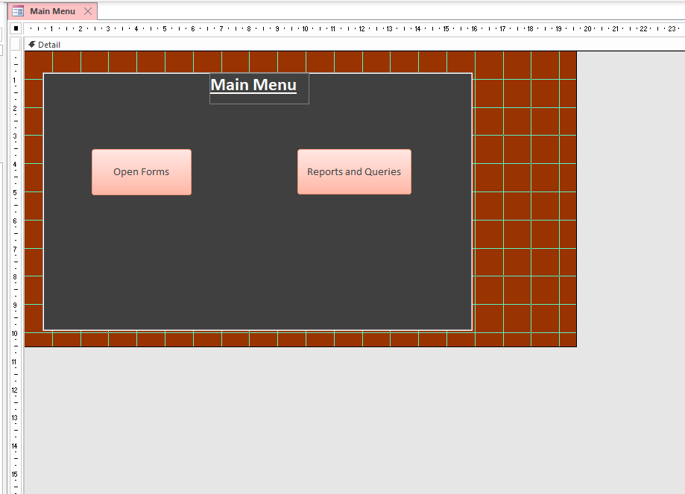

Once logged in, users have access to big buttons which users can click on and navigate through each page

### Form Page

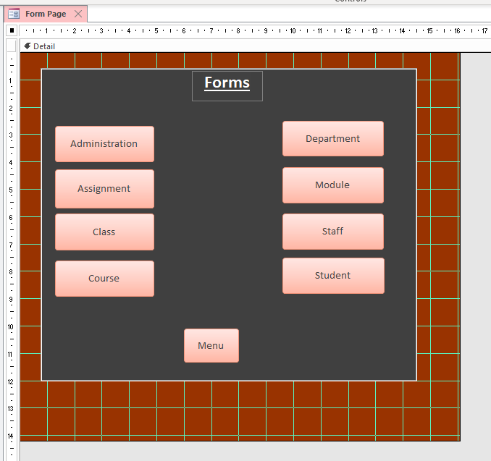

In this page, the users have access to each page and can return to the main menu page with the back button

### Administration Form

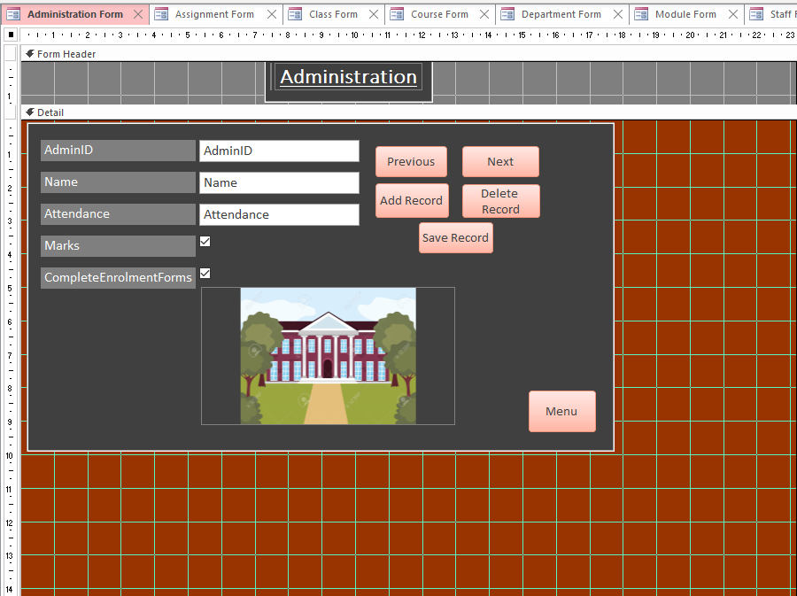

In all the forms, there’s multiple buttons which users can interact with. Next and Previous will navigate between each record. Add will allow users to add records which you can Save with. If a recorded is no longer necessary, the users can Delete the record. When a record needed to be edited, they can be changed and saved.

### Assignment Form

### Class Form

### Course Form

### Department Form

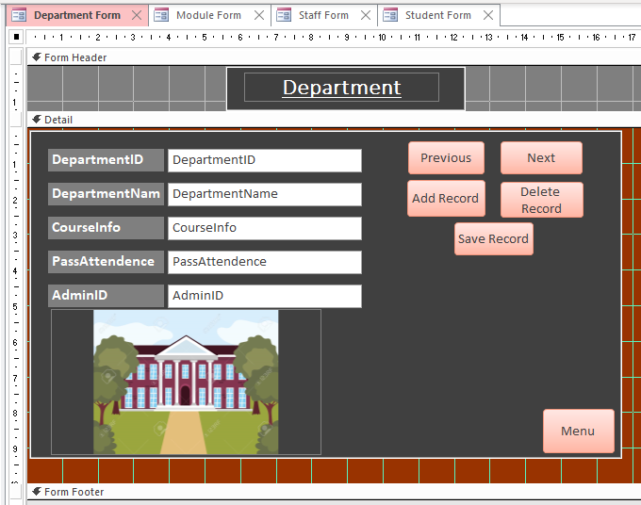

### Module Form

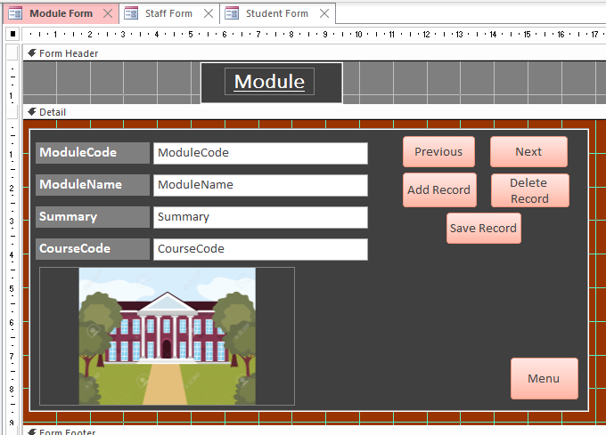`

### Staff Form

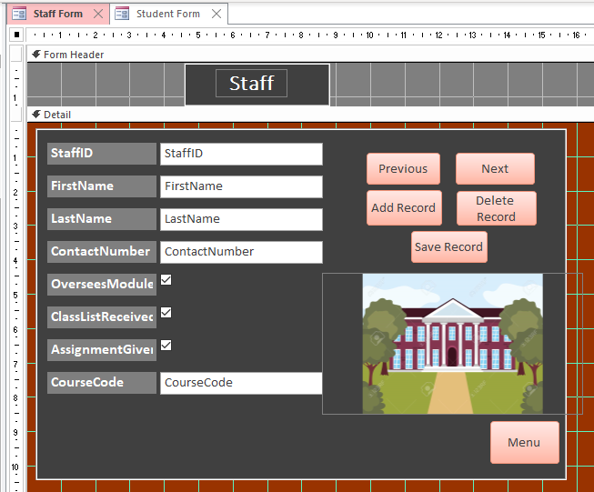

### Student Form

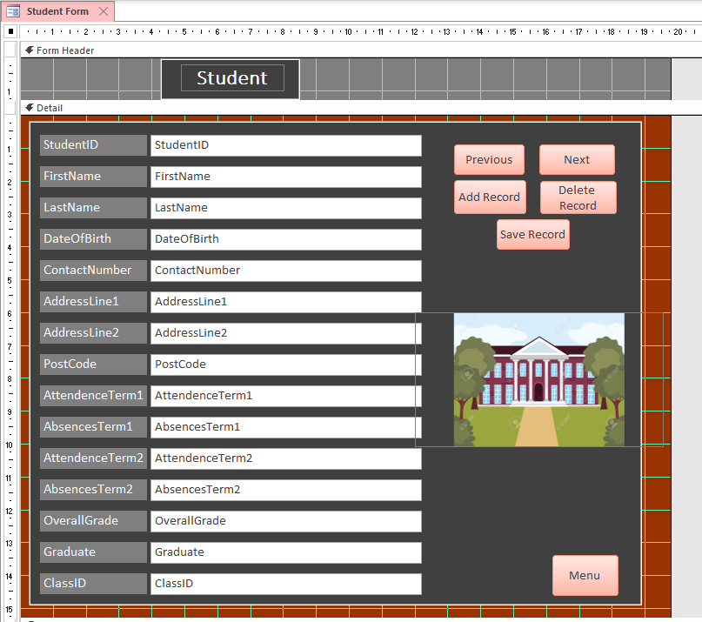

### Queries and Report

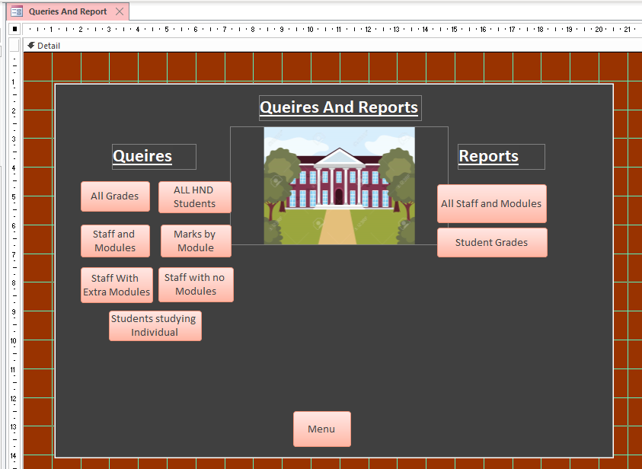

On this page, the users can click on Queries which will search for specific requirements within the database. This page will also produce reports within the current database as well.

## Form View

### Splash Screen

### Login Screen

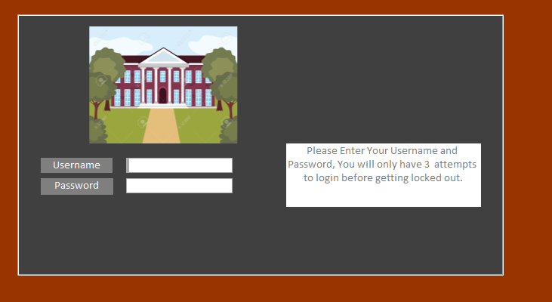

### Main Menu

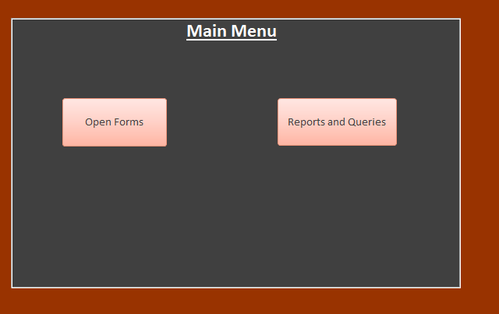

### Forms

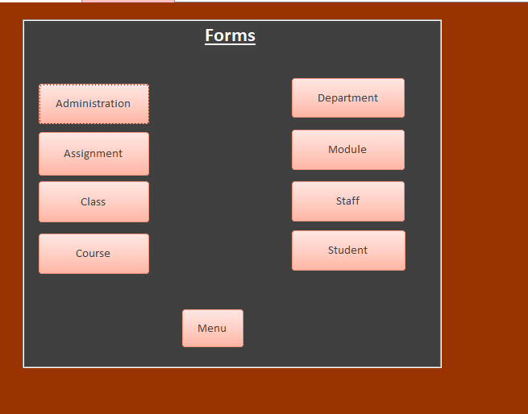

## Administration

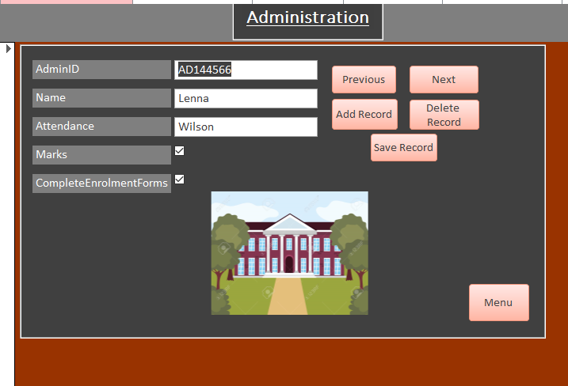

### Assignment

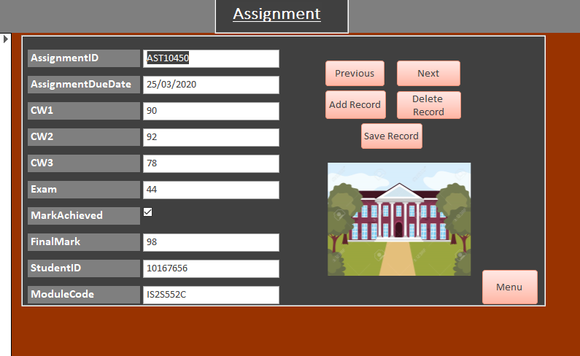

### Class

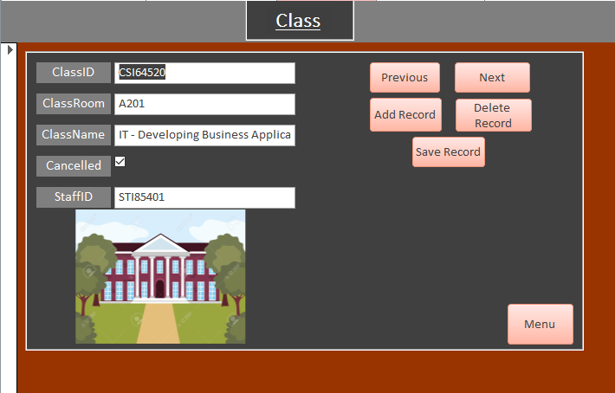

### Course

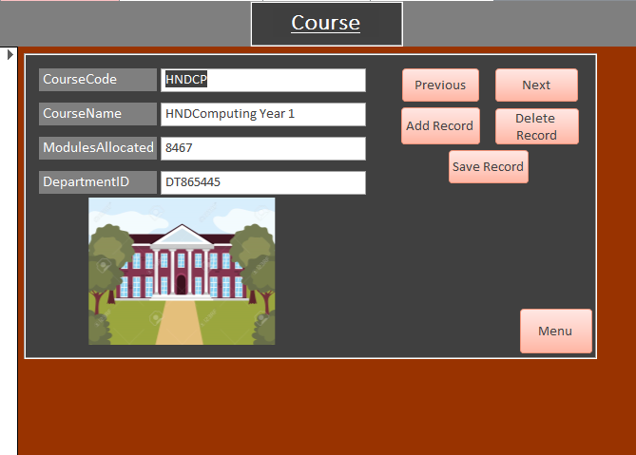

### Department

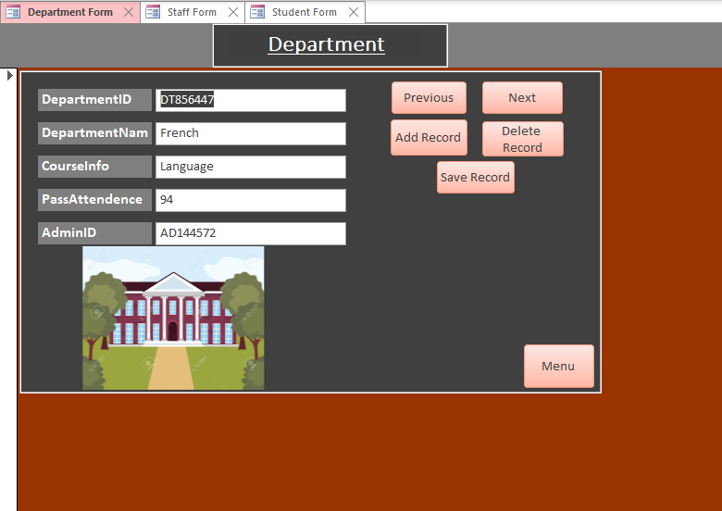

### Staff

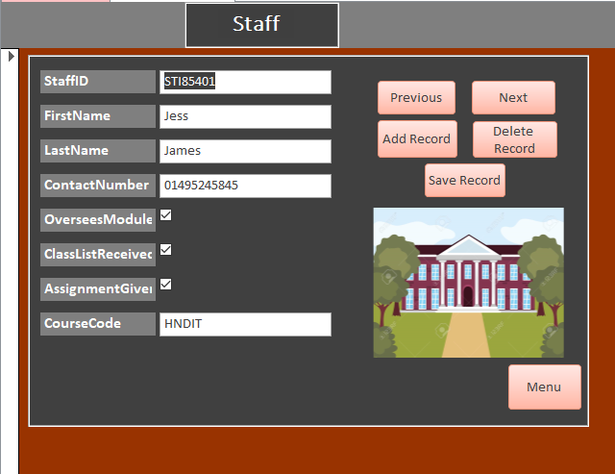

### Student

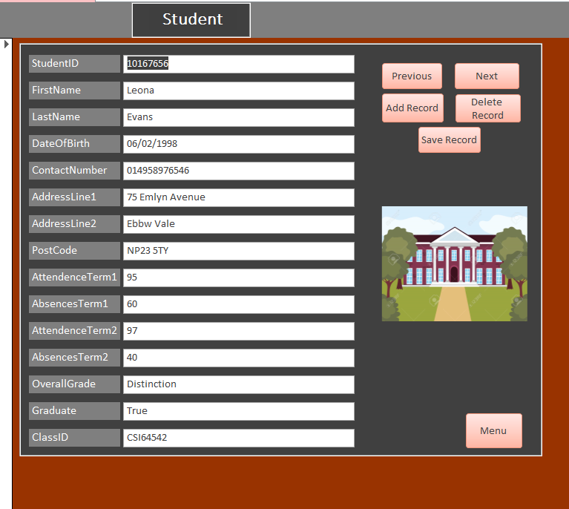

### Queries and Reports

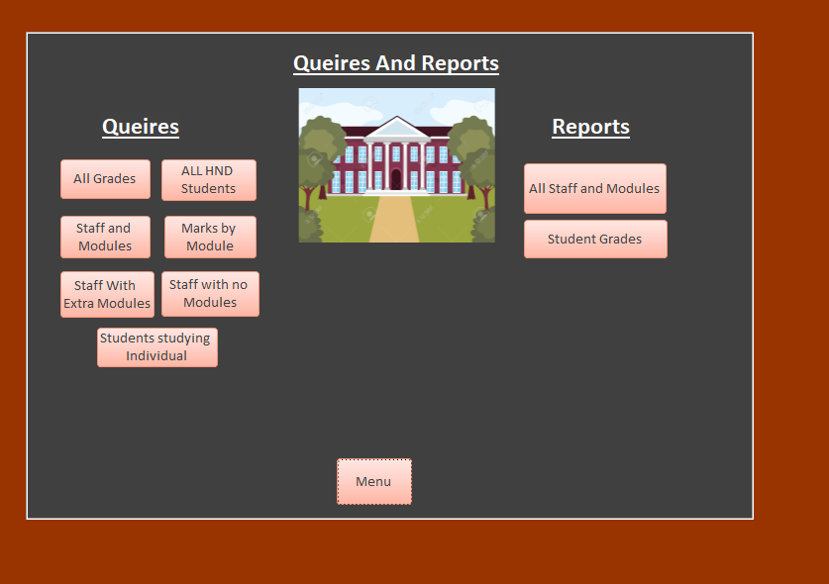

# Quires and Reports

These following screenshots will show the SQL Code for the Queries that I possess within this database and explain to how they work and what they are meant to do. For the reports, I will display both design view and preview form to show how they look as a print layout.

## All grades

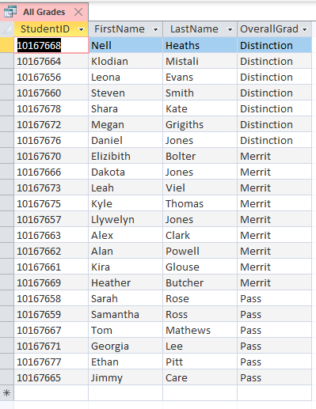

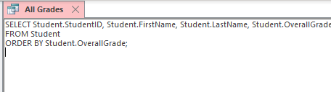

This query searches for all students with their name id and overall grade

## All Staff and Modules

This Query Searches for all the staff and modules that they are associated within the database

## Marks Search by Module Name

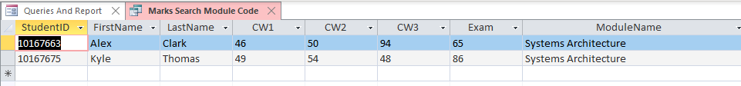



This module allows user to search for the name of each module and see the marks that students have gotten within that module

## Extra Modules

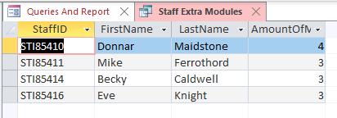

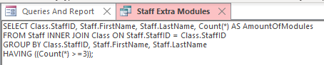

This query searches for staffs that have more modules over an x value of modules, in this case I used more than three modules and 4 staff members popped up

## Reports

### All staff and Modules

This the report in the preview mode, as you can see, it’s a clean report which displays all staffs with the modules code and staff code so users can see which staff are associated to each course

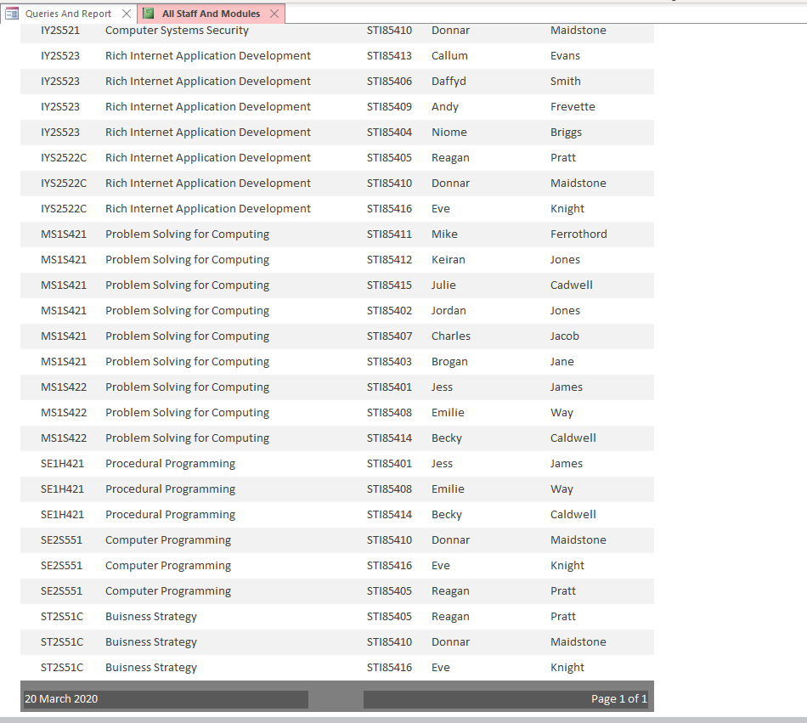

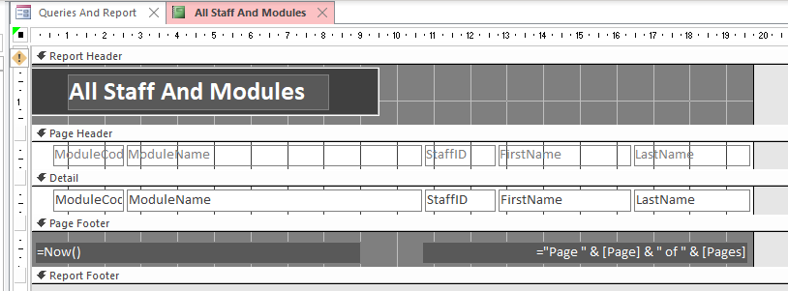

In design view, the interface is small and compact making it easy to design and edit

### Student Grades

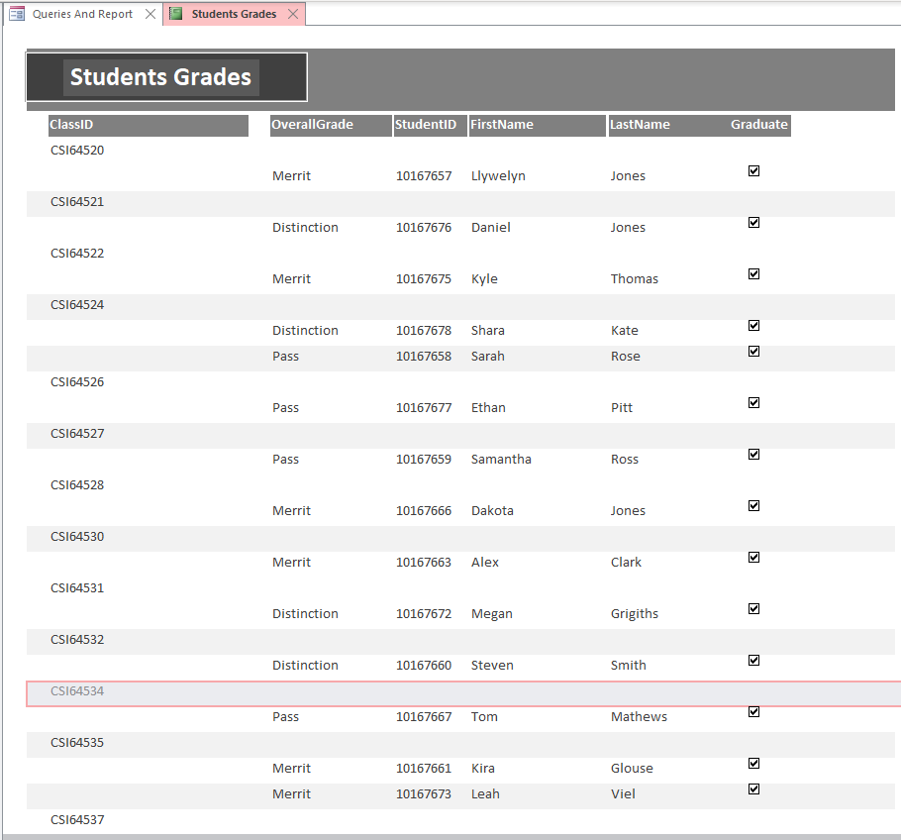

This report shows all of the students grades and if they can graduate, on this report list you can also see the class id associated with the class they passed within.

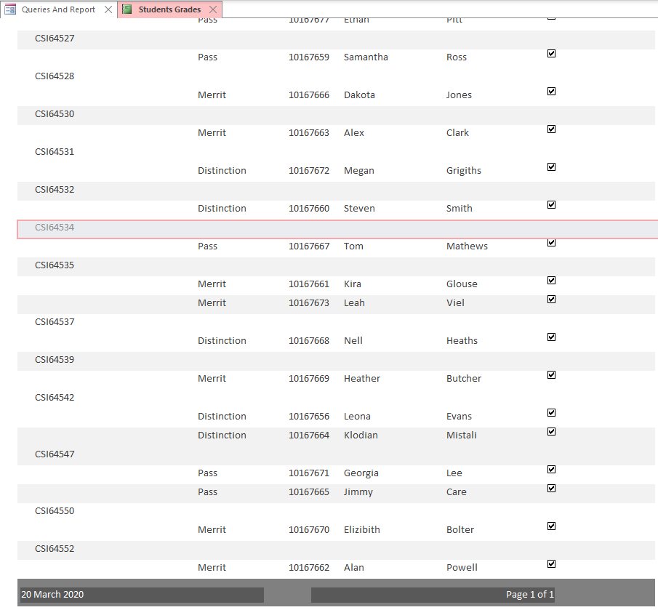

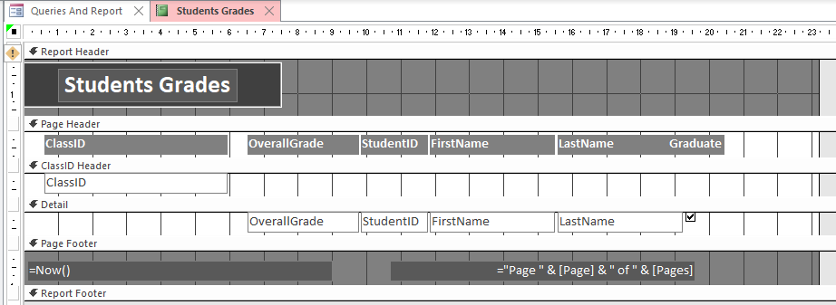

# Conclusion

To conclude this assignment, I feel as I have done well implementing my diagrams and entity relationships into this database. I feel as the database is as I envisioned, and the database is easy to follow. The GUI is clean and not hard to look at in any lighting, it is also aesthetically pleasing to look at with the simple pictures making it warmer to look at. Using a different approach to this database with SQL, I’ve learnt a lot through using queries this way and creating tables. although Where I fall short in this assignment is that I couldn’t get some of my queries to work which if provided more time, I would have optimised and try to get them to work, I unfortunately didn’t give myself enough time management due to my project getting corrupted twice so I also spread through some section which has also caused me to fallback and sacrifice quality. But overall, I think I have achieved a database which functions as it should and provides a basis for a company that can use this interface